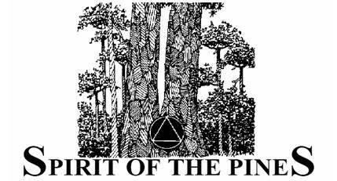
FRIDAY
4:00 PM | Registration Begins – Nexus
5:30 PM | “Why we are here”- O’Dome
6:30-7:30 PM | Dinner - Chow Hall
7:45-8:30 PM | Barefoot Meeting – O’Dome  (Introduce committee at Beginning)
8:30 PM | Snack Time - Chow Hall
8:45-9:45 PM | Young Sobriety Speaker Mtg – O’Dome
10:00 PM  10:00 PM | “Ask it Basket” – O’Dome  Meditation Meeting – O’Dome upstairs
SATURDAY
7:00 - 9:00 AM Individual Meditation – Chapel
8:00 AM Breakfast – Chow Hall
9:00 AM Alanon Meeting – O’Dome upstairs
9:00 AM Smokers Meeting – smoking section
9:00 AM Big Book Study Meeting – O’Dome
10:00 AM Break
10:30 AM Step Meetings – O’Dome
12:00 Noon Lunch – Chow Hall
1:30 PM Sponsorship Meeting – O’Dome
1:30 PM ACOA Meeting – O’Dome upstairs
3:00 PM Mens Meeting – O’Dome
(Please allow privacy for attendees)
3:00 PM Womens Meeting – O’Dome upstairs
4:15 PM Traditions Meeting – O’Dome
4:15 PM Committee Meeting – Chow Hall
5:30 PM Dinner – Chow Hall
6:30 PM Spirit Group Conscience – O’Dome
(Open to All)
7:15 PM Speaker Meeting – O’Dome
8:30 PM Snack Time – Chow Hall
8:45 PM Birthday Meeting O’Dome
10:15 PM Relationship Meeting – O’Dome
10:15 PM Bonfire Meeting - Lake
(campfire picture on map)

SUNDAY
7:00-9:00 AM Individual Meditation - Chapel
8:00 AM Breakfast - Chow Hall
8:30 AM Meditation Meeting - Upstairs O-Dome
(Doors locked at 8:30 to allow undisturbed meditation)
9:30 AM Speaker Meeting – O’Dome
10:30 AM God as You Understand Him Meeting
(The God Meeting) – O’Dome
12:00 Noon Cleanup/Departure

Camp Olympia requires that the cabins and bathhouses be fully cleaned, swept and garbage emptied before we depart. This is a part of our guarantee to use these facilities for the next Spirit of the Pines.

Now is the time to volunteer for 12th Step Work! The camp Must be left clean. 
 All cabins are cleaned and vacated

Please volunteer with the conference chairpersons or committee members.

All personal belongings left in cabins will be removed. If turned in to the Spirit Committee, items will be brought to the next Spirit.

